The engage in their future 2020 National Football Tournament at WHSS.
(By Harvey B)
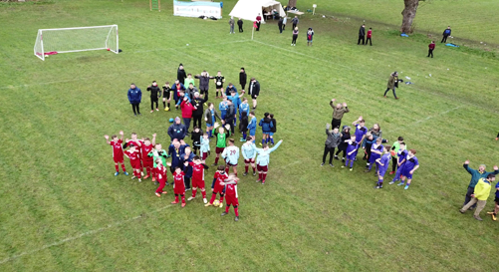

Once again, the WHSS were the hosts for the engage in their future Football Tournament run each year for social, emotional, mental health education schools both locally and nationally. This year 100 students attended from 7 schools including WHSS who were fantastic hosts once again.
WHSS first match was not the best of starts as we lost 3-1 however the school spirit shone through and we went on to win 3 matches, draw 1 match and only loose 2 matches out of the 6 games that we played.
Paul P led our team up front with some fantastic ball skills and pressure while in the mid field Ben S, Tom B and Tom K showed a really positive attitude and sportsmanship throughout the matches with their passing and tackling setting up their chances to score. Ethan P and Harvey B played at the back showing versatility and adaptability by being where and when they were needed proving to be invaluable to the overall team spirit. In goal was Rhian G who made some spectacular saves when they were needed to keep us in the game.
The tournament was again a fantastic experience for everyone - competitors and spectators - with many new friends made and lots of compliments given to the school, participants and organisers at the school.
Over all the sportsmanship shown by everyone involved was incredible and we all look forward to next year and maybe a win for WHSS.

