Biographical profile
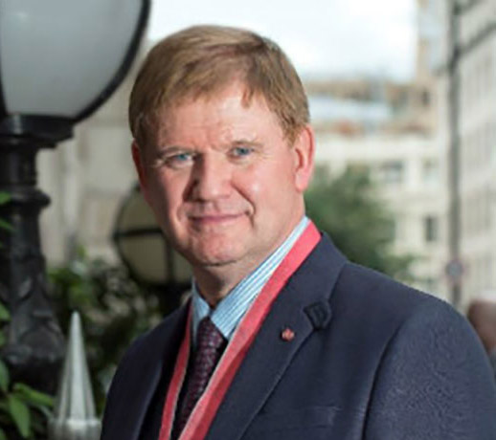
Barry Carpenter was recently appointed to the UK’s first Professorship in Mental Health in Education, at Oxford Brookes University. He is Honorary Professor at universities in the Ireland, Germany and Australia. He has been a Fellow of the University of Oxford.
He has been awarded an OBE and CBE by the Queen for services to children with Special Needs. In 2017 he was entered into "Who’s Who" in acknowledgement of his national and international contribution to the field of Special Education.
In a career spanning more than 40 years, Barry has held the leadership positions of Headteacher, Principal, Academic Director, Chief Executive, Inspector of Schools and Director of the Centre for Special Education at Westminster College, Oxford. In 2009, he was appointed by the Secretary of State for Education as National Director for the Children with Complex Learning Difficulties and Disabilities Research Project. The Engagement approach advocated from this work has become the foundation for the recommendations made by the Rochford Review around assessment .
He is the author of over 150 articles and many texts on a range of learning disability/special needs topics. In the last 12 months, his work has been translated into German, French, Dutch Russian and later this year , Chinese. He has written books (with Carolyn Blackburn and Jo Egerton) which focus upon Fetal Alcohol Spectrum Disorders (FASD)., and he co-authored the seminal book , "Engaging Learners with Complex Needs" (Routledge).
Barry lectures nationally and internationally. In recent years this has included China, Japan, Abu Dhabi, and Germany. He is currently Chair of the National Forum on Girls and Autism , which is the focus of his latest book, ( with Francesca Happe and Jo Egerton.) .In 2019, as part of the Launch of the ‘ Girls and Autism ‘ book , he has given lectures in Australia , New Zealand. USA, Norway, Ireland , Turkey and Dubai . He is the co-founder of the National Forum for Neuroscience in Special Education. For the Mental Health Foundation, he Chaired the National Inquiry into the Mental Health of Young People with Learning Disabilities.
Barry has 3 children – one a School Principal, one a Senior Occupational Therapist and a daughter with Down’s Syndrome, who now has a home of her own, published her first book in 2017, and is on an Apprenticeship as a Teaching Assistant.

